Part A

For part A, as we can see in the question request, it said we need to move and rotate the camera follow the action of the left and middle button on the mouse.

Looking through the lecture 14 p8, we get this picture:

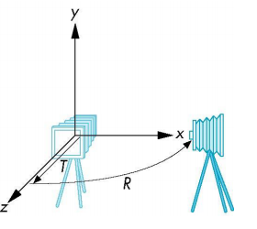

So it means we need to rotate the camera on the x and y axis.

Here are some pictures to make more sense:

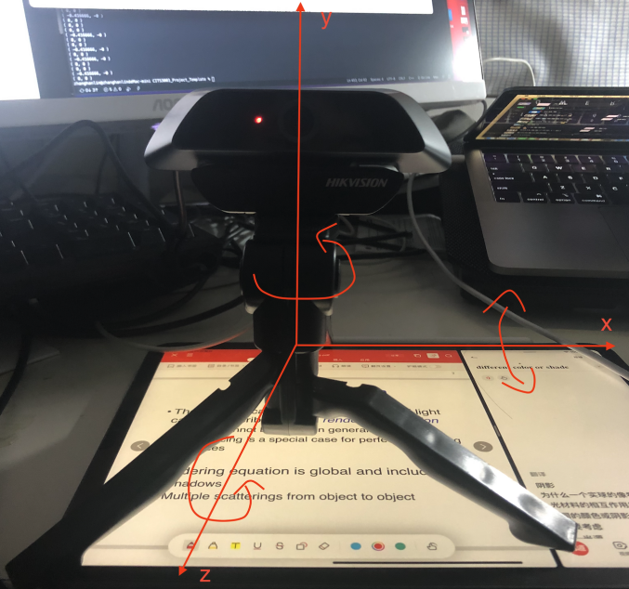

Rotate X:

The camera rotate on x-axis if you compare with the origin picture

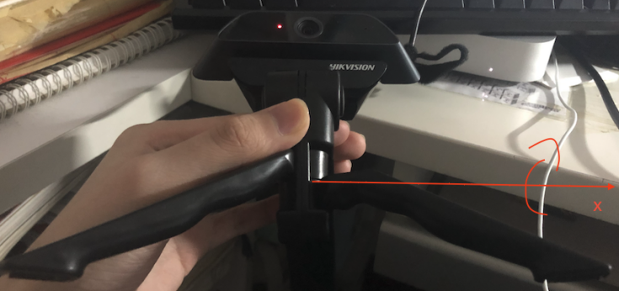

Rotate Y:

The camera rotate on y-axis if you compare with the origin picture

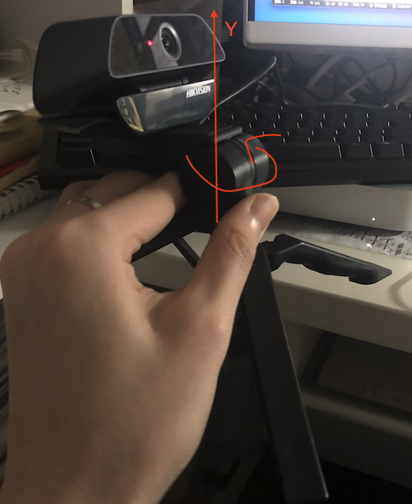

Rotate Z:

The camera rotate on z-axis if you compare with the origin picture

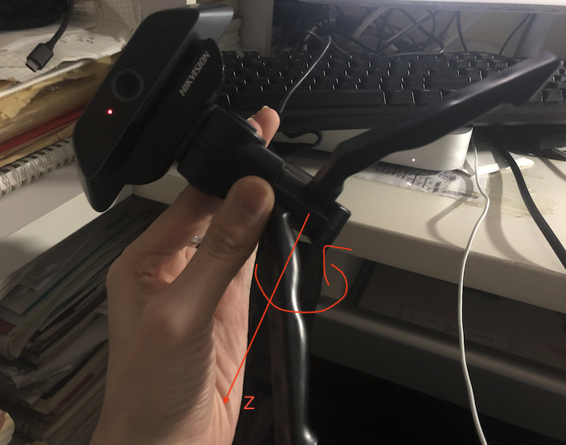



Also, from the lecture 14, we learn a formula at p8:

Since we need to rotate an x-axis and y-axis, so we get the code below:



Part B

Similar to part A, but this time we need to change the angle of the object (rotate the object).

Original object:

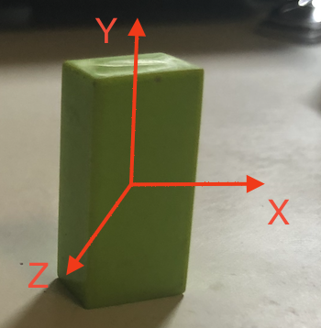

Rotate X:

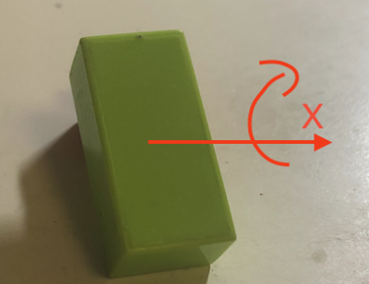

Rotate Y:

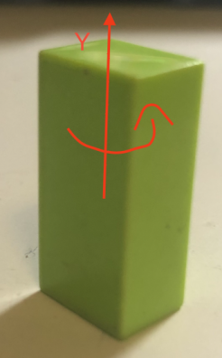

Rotate Z:

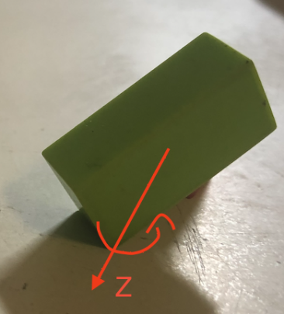

So in this part, we need to consider all of the situations, rotate x-axis, y-axis, z-axis.

As we know, inside of the structure “SceneObject”, it contains a float list named angles which contains the rotations around X,Y and Z axes.

Finally, based on the last part and the information we get from this part, we get code below:



Part C

Same with what we know from the question request, it ask us to modify the function below:

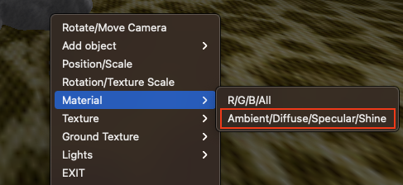

So, we need to go to the function “makeMenu” first. According to this, we know ID for “R/G/B/ALL” is 10 and ID for “Ambient/Diffuse/Specular/Shine” is 20 (name of this function already been changed to match the demo video). Then we go back to the function “materialMenu”.

First, we need to follow the code for “R/G/B/ALL” part, so that is why we add a else if statement with condition “id == 20”, it is for “Ambient/Diffuse/Specular/Shine” part.

Set the toolObj to be the current object, next we need to add a “setToolCallbacks” function.

After checking the file “gnatidread.h”, we get this below from the file:

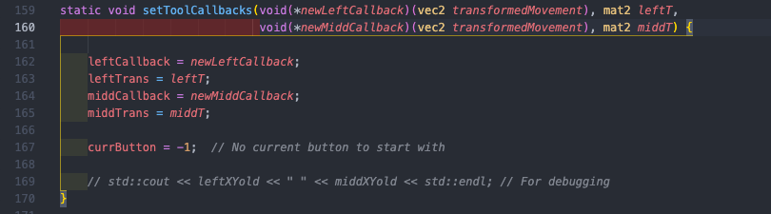

The func1 which call inside of “setToolCallbacks” follow the action of mouse left button and func2 follow the action of mouse middle button.

Now it is time to make func1 and fun2. func1 to adjust ambient and diffuse, func2 to adjust specular and shine.

Follow the both call functions of setToolCallbacks: “adjustRedGreen” and “adjustBlueBrightness” for part “R/G/B/ALL” in function materialMenu, we can know how to build the function “adjust_ambient_diffuse” and “adjust_specular_shine”. Finally we get the code below:

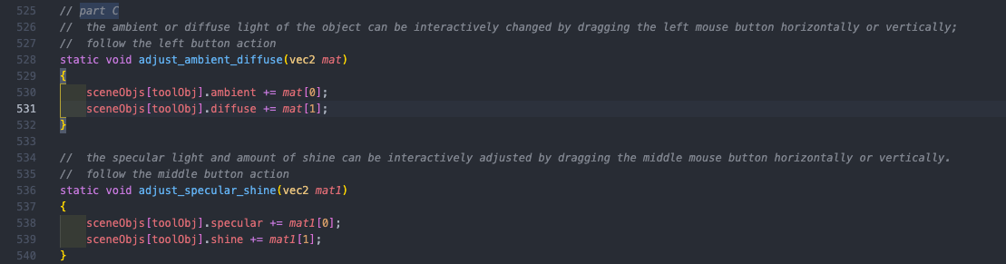

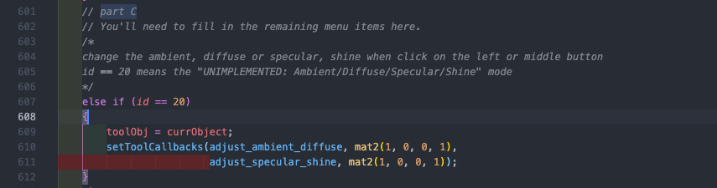

Change in function “makeMenu” is only change the function name of the “UNDEFINED: Ambient/Diffuse/Specular/Shine”, so no screenshot post here.

Part D

Just makes the near distance smaller, that is all.

Part E

We did the similar thing in lab 5 (week 6), so we now has this image:

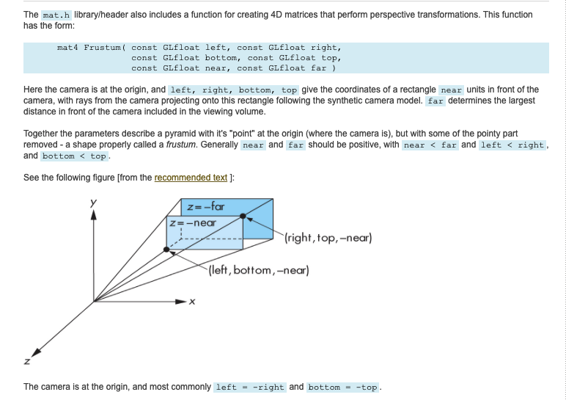

Then we know we need if-else statement for width < height and width >= height. For width < height, we need to change bottom and top value, otherwise we need to change left and right value.

Based on this, we get:

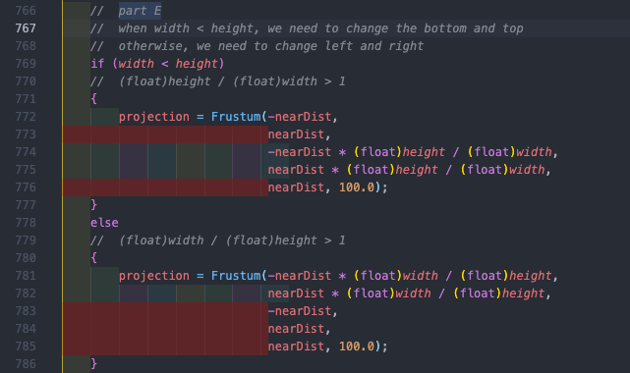

Part F

For this one, we need to modify the vertex shader so that the light reduces with distance. To achieve this, we go back to lecture 15 p15.

Now we get the formula below (where *d*𝑑 is the distance from light source):



After adjust the number of a, b, c to make the result better, we get code below:

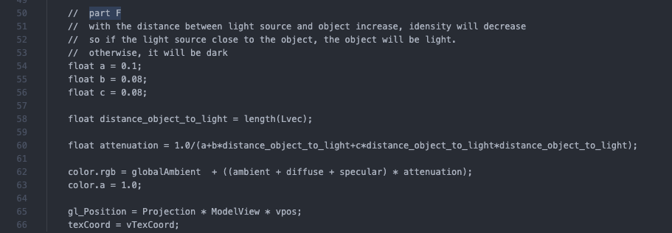

With the distance between light source and object increase, idensity will decrease. So, if the light source close to the object, the object will be light. Otherwise, it will be dark.

Part G

The lighting calculations in the fragment shader, so that the directions are calculated for individual fragments rather than for the vertices.

Nothing need to change in .cpp file, only need to change vertex shader and fragment shader. Just copy and paste the part from vertex shader to fragment shader and pass the variables from vertex shader to fragment shader.

Not too sure do we need to change the sceneObjs[nObjects].rgb[0],[1],[2] to be 1.0 inside of the addObject( ) function, since the white light color is 1.0, 1.0, 1.0 not 0.7, 0.7, 0.7. But in the request it said “Generally specular highlights tend towards white”, maybe no need?

Reference

1. How glGetUniformLocation works? (For part H)

<https://www.khronos.org/registry/OpenGL-Refpages/gl4/html/glGetUniformLocation.xhtml>

2. GLSL Programming/GLUT/Specular Highlights (For part G)

<https://en.wikibooks.org/wiki/GLSL_Programming/GLUT/Specular_Highlights>

1. RGB color examples (For part G)

<https://www.tug.org/pracjourn/2007-4/walden/color.pdf>

4.